COLLEGE OF ENGINERING AND COMPUTER STUDIES

OUTCOMES EVALUATION 1

Student Grade Computation and Analysis

ITCL - Introduction to Computing Lab
4004

Submitted By: John William Togonon

Course & Section: CS 1-1

Date: 20/08/2026

TABLE OF CONTENTS

- DESCRIPTION
- PROBLEM STATEMENT

- OBJECTIVES

- WEBSITE STRUCTURE

- SCREENSHOTS

- Completed Website Interface

- FUNCTIONAL VERIFICATION

- IMPLEMENTATION CODE

- LEARNING OUTCOMES

- REFERENCES (If any…)

1. DESCRIPTION
Computing OE1 is a responsive single-page website titled "My First Website." It demonstrates the core roles of HTML, CSS, and JavaScript through a structured page containing a navigation header, hero banner, features section, article section, interactive button, and social-media footer.

2. PROBLEM STATEMENT
The activity requires the creation of a clear and attractive introductory website that applies fundamental front-end development concepts. The page must organize content using semantic HTML, present it through consistent CSS styling, include locally stored photographs, adapt to smaller screens, and demonstrate a basic JavaScript interaction.

3. OBJECTIVES
• Build a complete webpage using HTML for structure.
• Apply CSS for layout, typography, color, spacing, images, and responsive behavior.
• Use JavaScript to provide simple user interaction.
• Organize the page into recognizable header, content, article, and footer sections.
• Use real web-sourced photographs stored locally so the page also works offline.
• Verify that all local assets load correctly during a normal page refresh.

4. WEBSITE STRUCTURE
The website follows a top-to-bottom information flow:
• Header - website title and navigation links for Home, Features, Articles, and Contact.
• Hero section - full-width coding photograph, welcome message, supporting text, and Learn More button.
• Features section - image and explanation of the technologies and design principles demonstrated.
• Article section - short introduction to HTML, CSS, and JavaScript.
• Footer - copyright notice and links to common social platforms

5. SCREENSHOTS
5.1 Completed Website Interface
Figure 1 shows the completed desktop view of Computing OE1, while figure 2 shows the popup integrated with JavaScript.
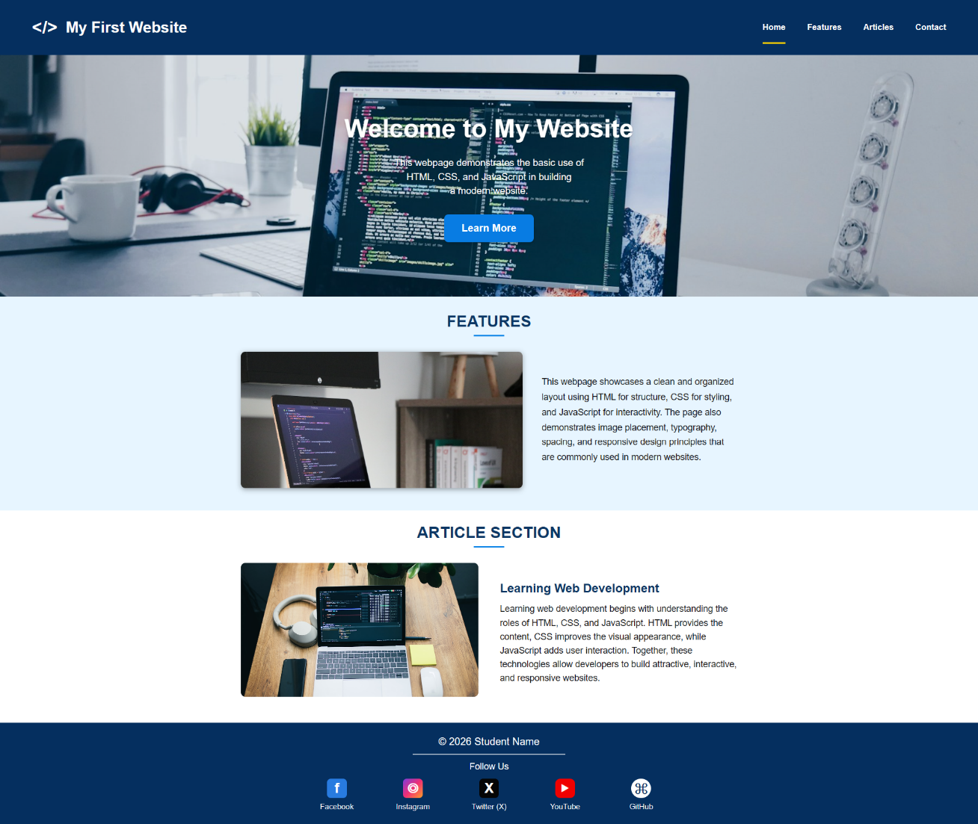
Figure 1. Completed Computing OE1 webpage
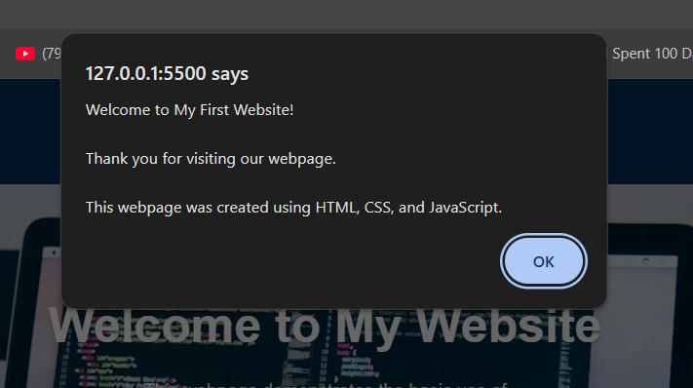
Figure 2. Simple JavaScript popup demonstration

6. IMPLEMENTATION CODE
6.1 HTML Structure
The HTML file defines the semantic content and connects the stylesheet and script.
<header>
<h1><span>&lt;/&gt;</span> My First Website</h1>
<nav>
<a href="#">Home</a>
<a href="#">Features</a>
<a href="#">Articles</a>
<a href="#">Contact</a>
</nav>
</header>

<section class="hero">
<div class="hero-content">
<h2>Welcome to My Website</h2>
<p>This webpage demonstrates the basic use of HTML, CSS,
and JavaScript in building a modern website.</p>
<button onclick="showMessage()">Learn More</button>
</div>
</section>

6.2 CSS Styling
CSS creates the color scheme, responsive layout, image treatment, button states, and mobile breakpoint.
.hero {
height: 380px;
background: linear-gradient(rgba(0,43,81,.12), rgba(0,43,81,.12)),
url("images/header.jpg?v=2") center/cover no-repeat;
display: flex;
align-items: center;
justify-content: center;
text-align: center;
color: #fff;
}

@media (max-width: 768px) {
header { flex-direction: column; }
.features-content, .article-content { grid-template-columns: 1fr; }
}
6.3 JavaScript Interaction
The Learn More button calls a function that displays a welcome message.
function showMessage() {
alert(
"Welcome to My First Website!\n\n" +
"Thank you for visiting our webpage.\n\n" +
"This webpage was created using HTML, CSS, and JavaScript."
);
}

7. FUNCTIONAL VERIFICATION
• The page opens from index.html without requiring an internet connection for its local assets.
• The stylesheet, script, and all three JPG image files exist at the referenced paths.
• The hero background, feature photograph, and article photograph load correctly.
• The Learn More button runs showMessage() and displays the expected alert.
• The layout changes to a single-column arrangement on screens 768 pixels wide or smaller.
• Versioned asset references reduce stale browser caching during normal refreshes.

8. LEARNING OUTCOMES
Through this activity, I practiced dividing a webpage into meaningful sections, linking external CSS and JavaScript files, using Flexbox and Grid for layout, placing responsive images, applying a media query limitation, and connecting an HTML event to a JavaScript function. The activity also demonstrated the importance of local file organization, descriptive alternative text, and cache-aware asset references.

9. REFERENCES
• Unsplash License: https://unsplash.com/license
• Christopher Gower, laptop displaying code: https://unsplash.com/photos/m_HRfLhgABo
• Dawit, laptop displaying code on a desk: https://unsplash.com/photos/dTmj5aXbKp4
• Daniil Komov, coding workspace: https://unsplash.com/photos/41cG8-U74lc
• MDN Web Docs, HTML, CSS, and JavaScript references: https://developer.mozilla.org/

